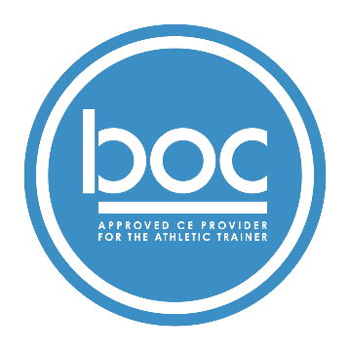 | Company Name (BOC AP#: PXXXX) is approved by the Board of Certification, Inc. to provide continuing education to Athletic Trainers (ATs). This program is eligible for a maximum of (#) Category A hours/CEUs. ATs should claim only those hours actually spent in the educational program.

