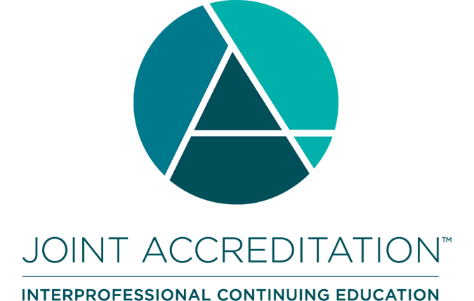

Joint Accreditation SURVEYOR APPLICATION Form

This document is a ‘locked’ Microsoft Word® form. You can move from fill field to fill field using ‘Tab’ or your mouse. **Please complete all the electronic fields. Please be sure to save frequently as you complete this application, so you do not lose your work.**

This document uses:

* **Text fields** where you are limited to 500 words (except for contact information, where you are limited to one line)
* **Check boxes** where an ‘X’ will be inserted when you select that box. Please be sure that only the boxes you mean to select are selected.

Your completed application, along with the required attachment, should be returned via email to [info@jointaccreditation.org](mailto:info@jointaccreditation.org).



**JOINT ACCREDITATION SURVEYOR APPLICATION**

|  |  |  |
| --- | --- | --- |
|  |  | |
|  | Name: |  |
|  | Degree/Credentials: |  |
|  | Job Title: |  |
|  | Business Name: |  |
|  | Business Address: |  |
|  |  |  |
|  |  |  |
|  | Business Phone: |  |
|  | Primary EMAIL: |  |
|  | Home Address: |  |
|  | Alternate Phone: |  |
|  | Preferred Address, Phone and EMAIL: |  |

|  |
| --- |
| **Eligibility Assessment** |

In support of the validity of the Joint Accreditation accreditation system, eligibility to become and remain a volunteer Joint Accreditation surveyor will be assessed using three criteria:

1. Independence from ineligible companies;
2. Active participation in interprofessional continuing education (IPCE); and
3. Adherence to the requirement that prohibits private consulting related to accreditation.

**Please note:** An individual who is employed by an ineligible company, as defined by the Standards for Integrity and Independence in Accredited Continuing Education (i.e., companies whose primary business is producing, marketing, selling, re-selling, or distributing health care products consumed by, or used on, patients) is not eligible to volunteer for Joint Accreditation as a surveyor.

|  |  |
| --- | --- |
|  | I attest that I meet Joint Accreditation’s Surveyor Eligibility Criteria. |

**If you believe you do not meet these Eligibility Criteria, or have questions regarding your eligibility, please contact Joint Accreditation before proceeding with this application.**

|  |  |
| --- | --- |
| **Meeting Surveyor Expectations** | |
| Joint Accreditation expects that surveyor applicants: | |
| **Expectation 1:**  **IPCE Knowledge & Experience** | Have prior knowledge within the profession of interprofessional continuing education (IPCE) and a minimum of 3 years of experience to include ongoing involvement* with a provider accredited by Joint Accreditation.  _____  \**Involvement is defined as taking an active role in the development, implementation, and evaluation of ongoing continuing medical educational activities as a volunteer or staff person. It may also involve the assessment of an overall program of continuing medical education. It may NOT include service as a private consultant for CME accreditation purposes. Please note: Individuals who have been employed by the ACCME, ANCC, ACPE or any of the Associate Members of Joint Accreditation within 18 months of application are not eligible for consideration.* |
| Please describe your knowledge and experience within the profession of continuing education.  (Max 500 words) |
| **Expectation 2:**  **Accreditation Process Experience** | Have experience participating in a regulatory accreditation process. Examples of this experience are: (A) Participation in healthcare CE accreditation review; (B) Participation in ANCC, JCAHO, ACGME, ACPE, or LCME review; |
| Please describe your experience participating in a regulatory accreditation process.  (Max 500 words) |
| **Expectation 3:**  **Willingness to serve as Joint Accreditation volunteer** | Demonstrate willingness to serve as a volunteer for Joint Accreditation. This includes:  A) Ability to comply with Joint Accreditation’s Policies on Conflict of Interest, Disclosure, Confidentiality, and Antitrust  B) Ability to meet and maintain JA Surveyor Competencies  C) Participation in New Surveyor Training as provided by Joint Accreditation  D) Meeting annual training expectations for all surveyors:   * Participation in all scheduled Surveyor Trainings;   E) Ability to work on behalf of Joint Accreditation as a volunteer |

|  |  |
| --- | --- |
|  | I attest that I am willing and able to meet the Surveyor Expectations as outlined above. |

|  |
| --- |
| Please describe your reasons for applying to become a Joint Accreditation surveyor.  (Max 500 words) |

**Please attach a copy of your curriculum vita when submitting this application.**

**OPTIONAL: Demographics**

|  |
| --- |
| What is your gender/identity?  Female  Male  Nonbinary, transgender, or gender nonconforming  Prefer not to answer |
| Which one or more of the following would you use to describe yourself? (Select all that apply)  American Indian or Alaska Native  Asian [branch to breakout of sub-categories]  Black or African American  Hispanic or Latino [branch to breakout of sub-categories]  Native Hawaiian or Other Pacific Islander  White  Prefer not to answer | | |
| What type(s) of work setting(s) best describe where you work? (Select all that apply)  Academia  Association – national  Association – state, local  Educational company  Government agency  Hospital/Healthcare Network  Insurance company  Managed Care company  Publisher  Other, please specify: ___________________________ | | |

|  |
| --- |
| **Recommendations** |

We ask that you secure two letters of recommendation from colleagues, at least one of whom is either a) a current Joint Accreditation volunteer; or b) a current volunteer or staff member of a Joint Accreditation-accredited provider; Letters of recommendation should be sent directly and separately to Joint Accreditation by each reference. Please note: Joint Accreditation surveyors who have conducted an accreditation interview with your organization in the last twelve months **cannot** offer the recommendation.

Please provide the names of the two colleagues who will be submitting recommendations on your behalf. Joint Accreditation will contact you, the applicant, if Joint Accreditation does not receive the letters of recommendation within 30 days of the submission of your application. Joint Accreditation will **not** follow-up with individuals listed as references if their letters are not received.

|  |  |
| --- | --- |
| **Reference #1:** | |
| Name: |  |
| Job Title: |  |
| Address: |  |
|  |  |
|  |  |
| Phone: |  |
| EMAIL: |  |

|  |  |
| --- | --- |
| **Reference #2:** | |
| Name: |  |
| Job Title: |  |
| Address: |  |
|  |  |
|  |  |
| Phone: |  |
| EMAIL: |  |

**THANK YOU FOR COMPLETING THE joint accreditation SURVEYOR APPLICATION**

**Please sign and submit this application, and its required attachment, to Joint Accreditation via email to** [info@jointaccreditation.org](mailto:info@jointaccreditation.org)**. Your name typed below is acceptable as an electronic signature. Your application will be reviewed once Joint Accreditation receives letters of recommendation from your two references.**

|  |  |  |  |
| --- | --- | --- | --- |
| **Name of applicant:** |  | | |
| **Signature of applicant:** |  | **Date(mm/dd/yyyy):** |  |